The first step: Measuring S-parameters with open circuit at port 2

The figure of the connection is as follows,

We get the screenshot of measurements as follows,

By using the markers, we recorded the S-parameter values for various frequencies into the table below:

|  |  |  |  |  |
| --- | --- | --- | --- | --- |
| Frequence | S11(dB) | S12(dB) | S21(dB) | S22(dB) |
| 2.0GHz | -9.19 | -0.2768 | -0.563 | -11.25 |
| 2.5GHz | -8.84 | -1.668 | -1.812 | -9.14 |
| 3.0GHz | -27.52 | -0.2593 | -0.3368 | -31.56 |
| 3.4GHz | -29.43 | -0.1854 | -0.3577 | -38.69 |
| 3.8GHz | -33.69 | -0.2114 | -0.3479 | -30 |
| 4.5GHz | -3.279 | -3.514 | -2.394 | -3.369 |
| 5.0GHz | -1.346 | -6.63 | -6.89 | -1.518 |

The second step: Measuring S-parameters with short circuit at port 2

The figure of the connection is as follows,

We get the screenshot of measurements as follows,

By using the markers, we recorded the S-parameter values for various frequencies into the table below:

|  |  |  |  |  |
| --- | --- | --- | --- | --- |
| Frequence | S11(dB) | S12(dB) | S21(dB) | S22(dB) |
| 2.0GHz | -6.36 | -1.724 | -1.635 | -7.41 |
| 2.5GHz | -8.72 | -1.484 | -2.083 | -9.12 |
| 3.0GHz | -33.02 | -0.1224 | -0.4326 | -35.97 |
| 3.4GHz | -30.13 | -0.0630 | -0.3917 | -30.22 |
| 3.8GHz | -28.76 | -0.1146 | -0.4136 | -31.99 |
| 4.5GHz | -20.82 | -0.743 | -1.602 | -24.95 |
| 5.0GHz | 0.4763 | -10.12 | -12.58 | -0.0069 |

The third step: Measuring S-parameters with matched load at port 2

The figure of the connection is as follows,

We get the screenshot of measurements as follows,

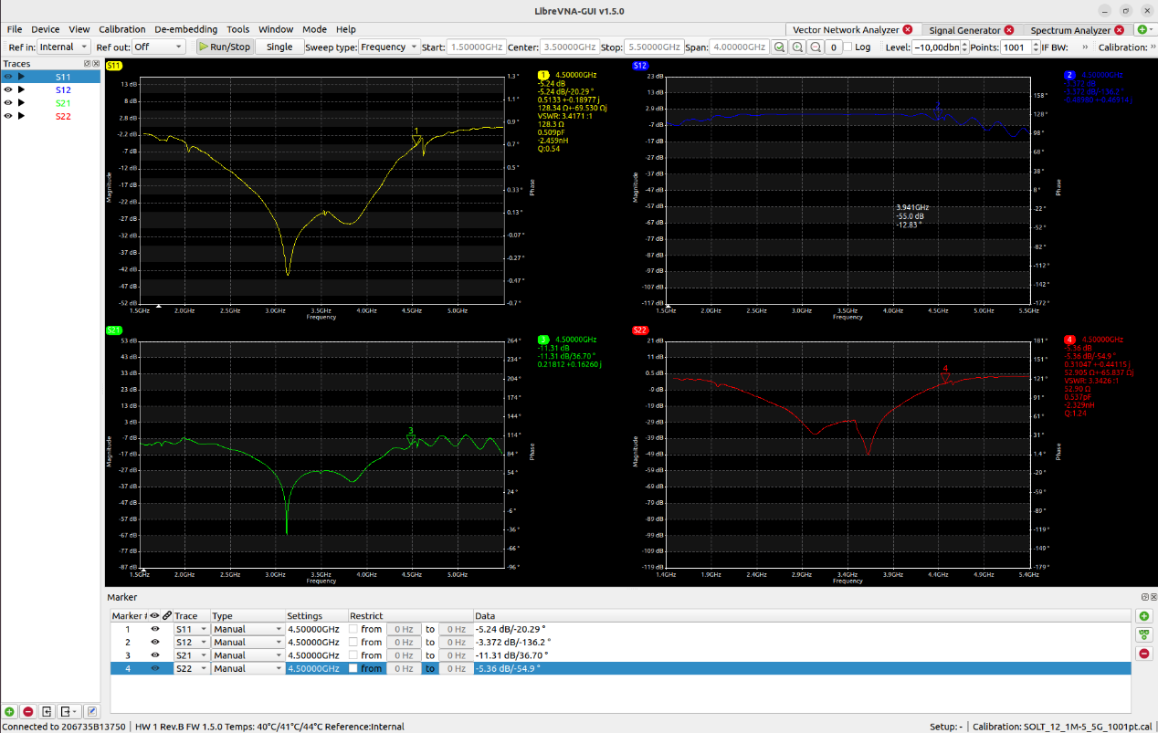

By using the markers, we recorded the S-parameter values for various frequencies into the table below:

|  |  |  |  |  |
| --- | --- | --- | --- | --- |
| Frequence | S11(dB) | S12(dB) | S21(dB) | S22(dB) |
| 2.0GHz | -6.94 | -3.62 | -6.61 | -7.27 |
| 2.5GHz | -13.85 | -0.909 | -13.69 | -15.35 |
| 3.0GHz | -31.52 | -0.0808 | -28.92 | -34.34 |
| 3.4GHz | -26.17 | -0.0946 | -27.92 | -28.68 |
| 3.8GHz | -28.31 | -0.2261 | -32.33 | -27.89 |
| 4.5GHz | -5.23 | -3.381 | -11.31 | -5.36 |
| 5.0GHz | -0.741 | -8.73 | -11.98 | -1.804 |

The fourth step: Effects of the calibration

When the calibration is on, the screenshot of S-parameters is as follows, same as the previous step,

When the calibration is off, the screenshot of S-parameters is as follows,

Why do the VNA's measured values for S-parameters change when the calibration is turned off?

VNAs require calibration to account for systematic errors that affect measurement accuracy. These errors can be due to a variety of factors, including the characteristics of the cables and connectors used, the directivity of the test port couplers, frequency response of the test setup, and more. When the VNA is calibrated, it measures these errors using known standards and applies corrections to the measurements it takes. If you turn the calibration off, the VNA no longer applies these corrections, so the measured S-parameters include the influence of the systematic errors, and thus they change. Typically, the measurements without calibration are less accurate and can show more variability or less expected behavior due to the uncorrected influences.

Why is the calibration needed?

Calibration is needed to ensure the accuracy and reliability of the measurements. VNAs are precision instruments that are capable of very accurate measurements, but only if the systematic errors are known and corrected for. Calibration involves measuring known standards (which have precise, characterized responses) so that the VNA can determine the systematic errors present in the measurement system. It can then mathematically remove these errors from subsequent measurements. This process is critical when trying to obtain accurate S-parameter measurements for devices under test, particularly in applications where precision is crucial, such as in RF engineering and communications system design. Calibration ensures that the measured data accurately reflects the true performance of the device under test, without being skewed by the characteristics of the measurement system itself.

Measurement: Whip antenna, short

Connected the devices as follows:

We could get the screenshot of S11 as follows:

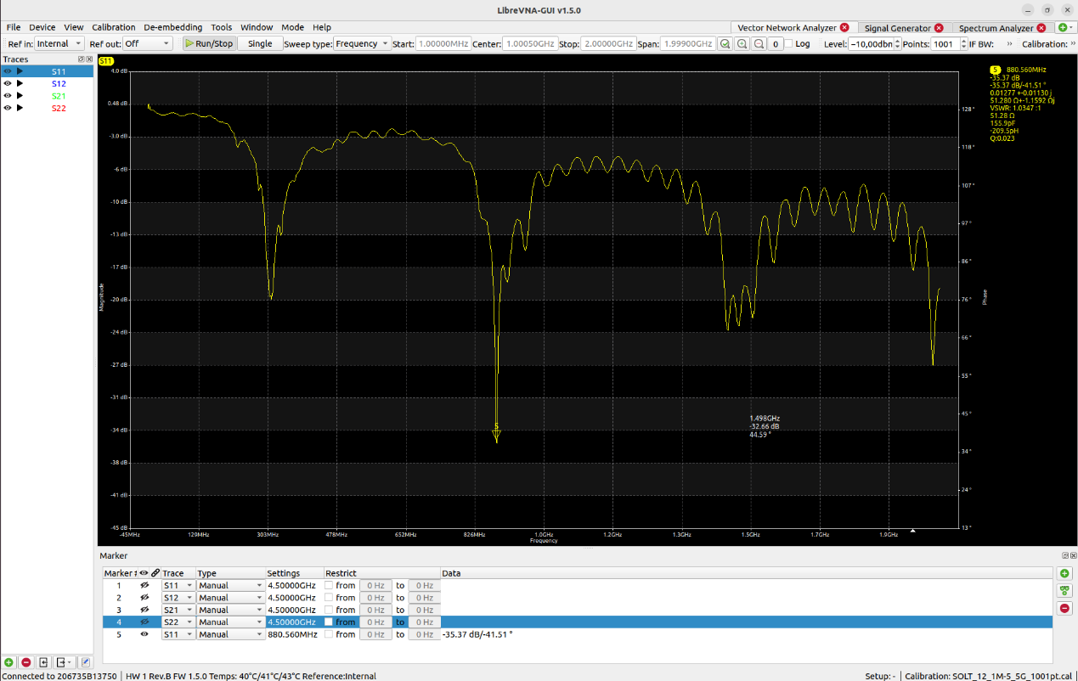

According to the screenshot of the S11 parameter, we could get that the resonance frequency of the antenna is the gap between the two notches, that is 880.560MHz, and the reflect energy is -35.37dB.

Measurement: Whip antenna, short

Same connection but extend the whip antenna as long as possible.

We could get the screenshot as follows,

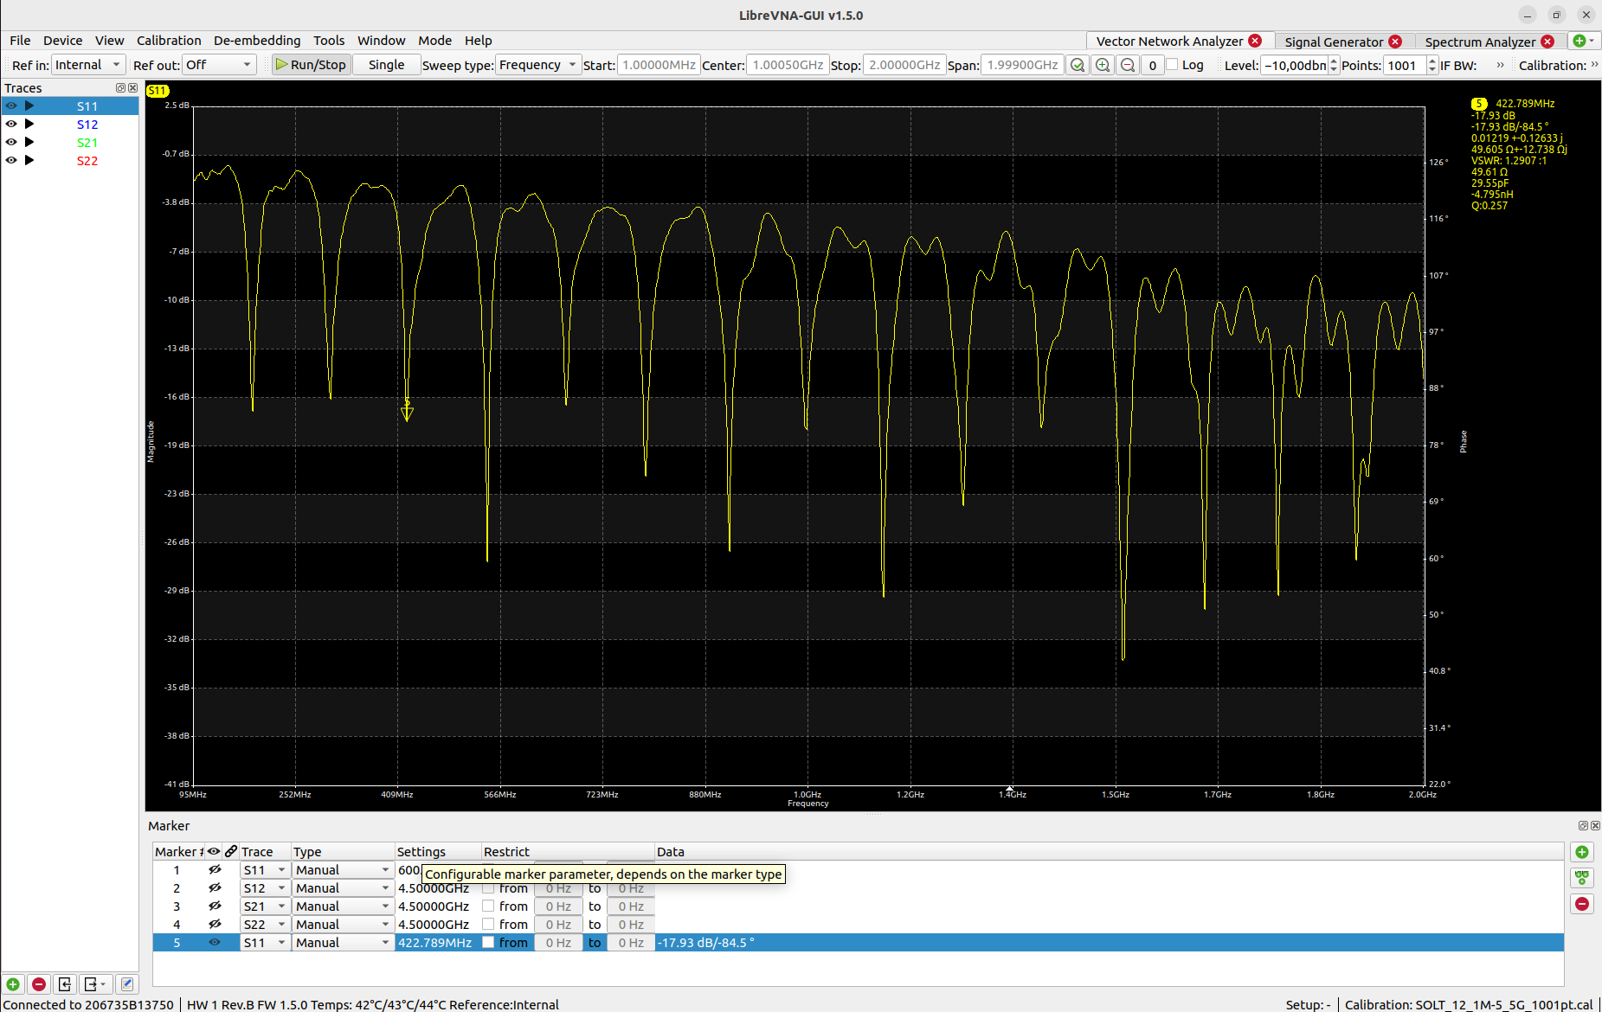

According to the screenshot of the S11 parameter, we could get that the resonance frequency of the antenna is the gap between the two notches, that is 546MHz, and the reflect energy is -27dB.

The reasons for the other notches on S11 plot could be as follows:

The antenna might have multiple resonant frequencies (multiband antenna), the antenna could be divided into different part to expand and shorten.

Imperfections or complexities in the antenna structure can introduce additional resonances.

The environment or the presence of nearby objects can affect the S11 plot, introducing additional notches. In the lab, there are at least ten antenna which could influence each other.

These notches could be the harmonics of the fundamental resonance frequency, which are multiples of the base resonant frequency. These are a natural phenomenon in antennas and circuits.